Programming Assignment 1

Of Mice and Meows
CSC460 Introduction to Artificial Intelligence & Machine Learning
Endicott College • Dr. Hank Feild
Spring 2026

Name(s): | Conrad Kadel, Teo Berbic
Programming Language: | Python

Overview
In this programming assignment, you will complete the implementation for A* and then add support for a problem I call "Of Mice and Meows" to this starter code. Here's an example starting state:

The agent, a cat, needs to capture all the mice and then go to the door. Traveling into a puddle (the blue spots) incurs a cost of 6 units, while traveling into any other spot incurs a cost of 1 unit (since cats aren't fond of water). Entering into a space that contains a mouse captures the mouse. The only valid goal state is when the cat is in the same spot as the door and all of the mice have been captured. No two types of spots may coincide. 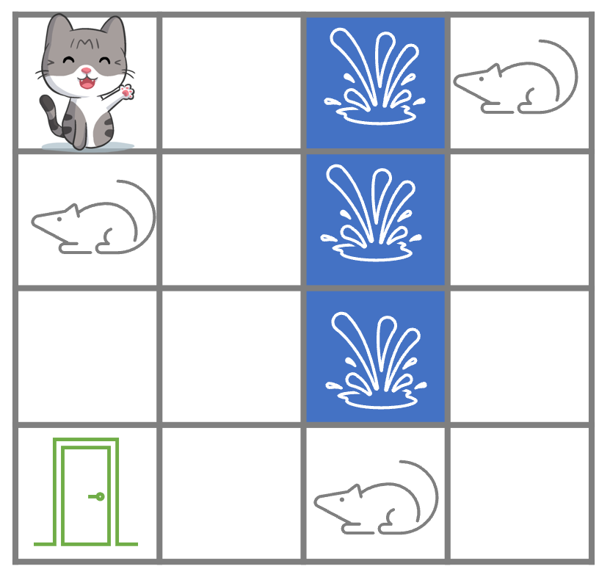

You will need to add a new problem class for this in your preferred language (Java or Python). This should include a parser for the file representing the starting state. You get to decide on the representation of input files, and so will need to include code to parse the format you decide on.

Unlike the maze example, which displayed the paths explored using the Drawer class, your version should do away with the graphical display all together. I've added support to suppress drawing (see the command line usage statement for the argument).

The starter code supports BFS, DFS, ID, UCS, and Greedy search. You are responsible for implementing A* and at least one heuristic that is not simply the Manhattan or Euclidean distance of the agent to the door. You should support the choice of one (for the Basic level) or two (for the Advanced level) heuristics for this problem. The user should be able to specify the heuristic to use via the command line, even if you have only implemented one heuristic.

Update the CLI usage statement and the README.md file with instructions for how to run your code (including valid options for heuristics and search strategies) and the accepted format of starting states for this problem.

Your implementation should handle any sized board, although you will find you will run out of memory pretty quickly for many of the strategies as the board size becomes marginally larger. As part of your fulfillment of this programming assignment, you need to complete the report at the end of this document. You also need to check off each of the specifications in the list below (click on a checkbox to toggle it).

Submit a completed PDF copy of this document (make a copy in your Google Drive, fill it out, then download it as a PDF before uploading) and a zip file of your entire codebase with your modifications.

You may work with a partner on this programming assignment. If you work with a partner, only one of you should submit.

Learning Outcomes
By the end of this assignment, you should demonstrate a mastery of the following:
- formulate a search problem in terms of its constituent parts: agent, actions, starting state, and goal test
- represent a search problem in such a way that it can be solved programmatically
- devise and implement heuristics for search problems
- evaluate the effectiveness of a heuristic

Specifications
Before you submit, go through and check off all of the specs your submission meets.

Your submission should meet each of the following criteria. It must pass all specifications in order to be contribute to your targeted grade bundle at the end of the semester:

Advanced

- every search algorithm supports both tree search (what is currently implemented) and graph search (see the Appendix bottom of this document for the pseudo code for graph search versus tree search) (DONE)
  - strategies:
    - BFS
    - DFS
    - ID
    - UCS
    - Greedy
    - A*
  - the user can specify which to use via a command line option
    - this is described in the CLI usage statement (DONE)
  - tree search is the default (DONE)
- two non-Manhattan, non-Euclidean heuristics (though they can contain one or both as part of a more complicated heuristic) (DONE)
  - one should be at least admissible (optimal for tree search) (DONE )
  - one should be consistent (optimal for graph search)—this can be the same one that is admissible (DONE)
  - the user can specify which of these to use via the CLI (DONE)
    - the help message describes what the heuristic options are for this problem
  - both heuristics are documented in the README, including in the usage examples
- the "Advanced" sections of the report are filled in and complete (DONE)

Basic

- the program compiles (for Java) and runs without error (Java and Python) (DONE)
- the source code is well organized and commented
  - successors are added in the order: left, up, right, down
- the A* algorithm is implemented correctly for tree search (Done)
- all algorithms produce a correct solution for tree search (Done)
  - BFS
  - DFS
  - ID
  - UCS
  - Greedy
  - A*
- UCS, and A* (with the heuristic you implemented) produce optimal solutions for tree search—these means your heuristic needs to be admissible (Done)
  - UCS
  - A*
- each source code file that you created or modified includes a header indicating who wrote or contributed to the code, including if Generative AI was used (Done)
- code from any outside sources, or code that relied on outside influence, includes a citation in a comment just above the corresponding code, including Generative AI (Done)
- the code includes an updated README.md
  - includes a specification of the format for Mouse and Meows starting states (what the input text file should look like) (Done)
  - explains how to run your code to solve the Mouse and Meows problem
  - includes a section that describes the heuristic(s) you implemented
  - includes a section that states who worked on the project (DONE)
  - includes any updates to the CLI (DONE)
- includes a board file in a mouse-and-meows/ directory for each of the scenarios described in the report text file
  - board1.txt
  - board2.txt
  - board3.txt
- as with the maze problem, if arguments are missing when running the Of Mice and Meows solver, an accurate and helpful usage statement is printed to the terminal with all implemented options specified (so update it as you implement things) (DONE)
- once a solution is found, stats (size, space, solution length, and solution path) are displayed to the terminal in a clear and readable format (DONE)
- the report below is filled out for all applicable questions (DONE)

Grading
As stated in the syllabus:

- Programming assignments. These can be done individually or in pairs. They will be assessed according to this general rubric, with specifics outlined for each assignment:
  - Excellent: All of the basic and advanced specifications are met.
  - Meets requirements: All of the basic specifications are met.
  - Revisions needed: A substantial effort was made to meet most of the basic specifications.
  - Unassessable: Nothing was submitted or what was submitted is unacceptably incomplete—a lot of work is required to get the submission up to the "Revisions needed" category.

Please see the syllabus for the grade bundles (and how many PAs you need in each of the EMRU categories) as well as details on late submissions and revisions.

Report

Heuristic
Describe the heuristic you came up with and implemented for the Basic level (this should be a heuristic that is optimal for A* with tree search).

The heuristic we came up with was to add the remaining number of mice to the length from the player to the closest mouse. If there are no mice left then we just return the distance to the goal. This way we could never overestimate the optimal distance to the goal.

Is it admissible? How do you know?

Yes, this is admissible because we never overestimate the distance to the goal. The true distance to the goal will always be greater than or equal to our estimate. Our heuristic cannot overshoot the actual distance at any point on the board because the true cost will never be smaller than the number of mice plus the distance to the closest one. This approach ensures a conservative estimate by focusing only on the closest mouse, adding the total count of mice further ensures we stay below the true cost even in unusual cases

Skip this question if you did not complete the advanced level.
If applicable, describe the heuristic you came up with and implemented for the Advanced level.

We came up with a heuristic that would combine the Manhattan distance of all mice together. In that way we were sure we could never overestimate the total distance to the goal. If there were no mice left, the heuristic would simply return the distance to the goal. Although we were unsure about how efficient this would be

Skip this question if you did not complete the advanced level.
Is it consistent? How do you know?

This heuristic is not consistent as we found out after experimenting. Although the first heuristic we build is consistent and consistent with A*. It finds the optimal solutions for the searches at any size of board and seems to be working very well for this type of problem.

Results: Board 1

An optimal solution should have a cost of 15.

Tree search (Basic level)

Search algorithm | States expanded | Max fringe size | Solution path length | Solution cost | Solution path
BFS | 7110 | 7709 | 11 | 31 | durrrldddll
DFS | 22 | 19 | 21 | 36 | dddrrruuudddluuuldddl
ID | 5299 | 14 | 11 | 16 | drrrudddlll
UCS | 1371 | 1103 | 15 | 15 | ddrdrruuudddlll
Greedy | 41 | 47 | 15 | 20 | ddrdrruuulllddd
A* | 41 | 47 | 15 | 15 | ddrdrruuudddlll

Are the relative performances consistent with what you expected? Explain.

Yes, we expected Greedy and A* to have the least number of states expanded and find the a good solution. Although we see that greedy is not optimal but A* is as it finds the cheapest solutions. ID finds a very interesting solution which Is almost optimal by one but for the complexity of the algorithm is surprisingly good.

Graph search (Advanced level)
Skip this table if you did not complete the advanced level.

Search algorithm | States expanded | Max fringe size | Solution path length | Solution cost | Solution path
BFS | 108 | 20 | 11 | 31 | durrrldddll
DFS | 22 | 14 | 15 | 15 | dddrrruuudddlll
ID | 775 | 15 | 15 | 15 | dddrrruuudddlll
UCS | 191 | 72 | 15 | 15 | ddrdrruuudddlll
Greedy (heuristic 1) | 48 | 37 | 17 | 32 | durdrddruuulllddd
Greedy  (heuristic 2) | 41 | 23 | 15 | 25 | rrrlldddrlluudd
A*  (heuristic 1) | 48 | 37 | 17 | 27 | durdrddruuudddlll
A*  (heuristic 2) | 108 | 52 | 15 | 15 | drddrruuudddlll

Are the relative performances consistent with what you expected? Explain.

No, we didn’t. Graph search significantly decreases the number of states expanded so we see that the solutions are very different. Interesting to see is that DFS ID and UCS are all optimal working with graph search. The smarter algorithms (greedy, A*) do not seem to be performing very well.

Results: Board 2

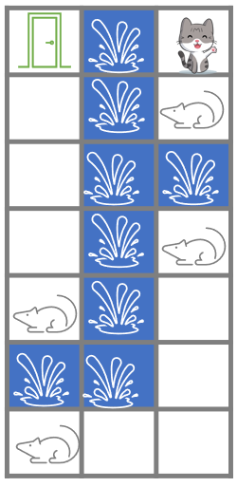

An optimal solution should have a cost of 24.

Tree search (Basic level)
Run each of these until they finish or crash. If you're using Java, set the heap size to something reasonably large given your computing constraints. See the README for details. If they crash or do not finish, input "DNF" in each cell of the row.

Search algorithm | States expanded | Max fringe size | Solution path length | Solution cost | Solution path
BFS | 86104 | 87514 | 14 | 34 | dddllddduuuuuu
DFS | 43 | 33 | 42 | 127 | ddddddluuuuruuldldddddrruuuuuuldddddluuuuu
ID | 39238 | 19 | 14 | 24 | ddddddlluuuuuu
UCS | 558 | 588 | 14 | 24 | ddddddlluuuuuu
Greedy | 259 | 221 | 20 | 70 | ddldrldddluruulduuuu
A* | 163 | 177 | 14 | 24 | ddddddlluuuuuu

Are the relative performances consistent with what you expected? Explain.

We kind of expected these results as this is a more complicated questions now. We see the full strength of A* as it gets the optimal solution with very little states expanded compare to other optimal solutions from ID and UCS.

Graph search (Advanced level)
Skip this table if you did not complete the advanced level.

Search algorithm | States expanded | Max fringe size | Solution path length | Solution cost | Solution path
BFS | 265 | 37 | 14 | 34 | dddllddduuuuuu
DFS | 35 | 21 | 34 | 64 | ddddddllrruuuuuullddddddrruuuuuull
ID | 1354 | 18 | 16 | 38 | ddddddlulduuuuuu
UCS | 197 | 119 | 14 | 24 | ddddddlluuuuuu
Greedy (heuristic 1) | 93 | 80 | 22 | 67 | llddddddruuuuruddlluuu
Greedy  (heuristic 2) | 74 | 63 | 22 | 92 | ddldddlduruurlddluuuuu
A*  (heuristic 1) | 98 | 84 | 22 | 67 | llddddddruuuuruddlluuu
A*  (heuristic 2) | 98 | 81 | 14 | 24 | ddddddlluuuuuu

Are the relative performances consistent with what you expected? Explain.

We did expect these results as again graph search seems to be significantly decreasing the number of states expanded. A* finds the only optimal solution but greedy finds it faster. Seems to decrease the number of expanded states for BSF the most

Results: Board 3
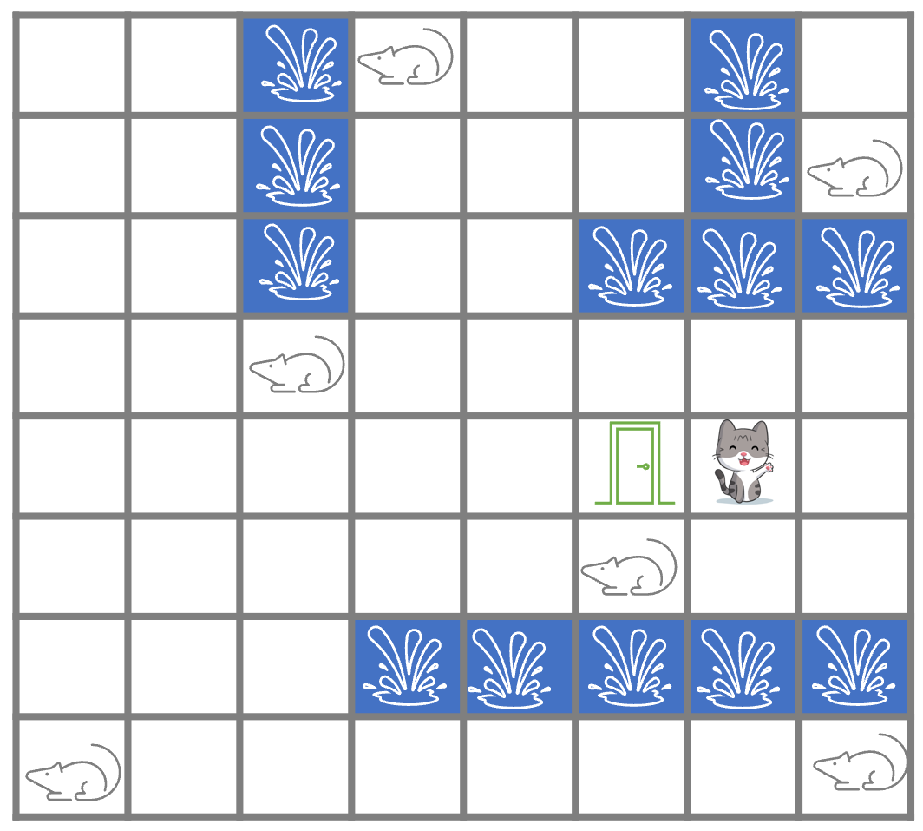
An optimal solution should have a cost of 48.

Tree search (Basic level)
Run each of these until they finish or crash. If you're using Java, set the heap size to something reasonably large given your computing constraints. See the README for details. If they crash or do not finish, input "DNF" in each cell of the row.

Search algorithm | States expanded | Max fringe size | Solution path length | Solution cost | Solution path
BFS | DNF | DNF | DNF | DNF | DNF
DFS | DNF | DNF | DNF | DNF | DNF
ID | DNF | DNF | DNF | DNF | DNF
UCS | DNF | DNF | DNF | DNF | DNF
Greedy | DNF | DNF | DNF | DNF | DNF
A* | DNF | DNF | DNF | DNF | DNF

Are the relative performances consistent with what you expected? Explain.

I didn’t expect all of them to be DNF but apparently when the problem gets bigger the amount of data necessary is significantly more to the amount that my computer cant even compute them (at sometimes even crashes). At least with tree search…

Graph search (Advanced level)
Skip this table if you did not complete the advanced level.

Search algorithm | States expanded | Max fringe size | Solution path length | Solution cost | Solution path
BFS | DNF | DNF | DNF | DNF | DNF
DFS | DNF | DNF | DNF | DNF | DNF
ID | 84619 | 85 | 71 | 141 | dddruuuuuuddddddluuuuuuulddddldddluuuuruuuldddddddluuuuddddluldrrrrruuu
UCS | 3197833 | 792714 | 31 | 46 | ruuullulldddlddlddlrrrrrrrluulu
Greedy (heuristic 1) | 529 | 502 | 71 | 141 | dlrddruuuulddlddluuuldddluullddrrrrrrruuuuuudddddluuuuuulddluuldddlrrrd
Greedy  (heuristic 2) | 776 | 339 | 61 | 141
A*  (heuristic 1) | 535 | 508 | 71 | 141 | dlrddruuuulddlddluuuldddluullddrrrrrrruuuuuudddddluuuuuulddluuldddlrrrd
A*  (heuristic 2) | 11033 | 1574 | 31 | 46 | uruulllludddlldldddrrrrrrrlluuu

Are the relative performances consistent with what you expected? Explain.

No, they were not as we were surprising to see the algorithm working with graph search and what is even nicer to see is that we found a solution that cost less than the projected solution or there was an error. All the other solutions we found seem to not be optimal.

Appendix
If you are attempting the Advanced level, here is the pseudo code for both Graph Search and
Tree Search. Note that in the tree search implementation in the starter code, cycles are detected, which is not something described in the Tree Search pseudocode below. "Frontier" is used in the pseudo code below in place of "fringe".

